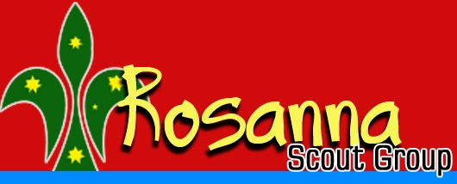

Rosanna Scout Group –
Annual Reports & Awards Presentation Night – Wed 18 Aug

With our new Group Leader and Committee coming on board in the last financial year, we’re now happy to be able to hold our first ever ARAP – Annual Reports & Awards Presentation night

Details:
Wednesday 18th Aug – 7:30-8:30pm – Rosanna Scout Hall
All Cubs, Scouts and families are invited
Cubs & Scouts in full uniform

Note that this will be replacing the Scout night for this week – the Scouts will be preparing and providing supper for us!



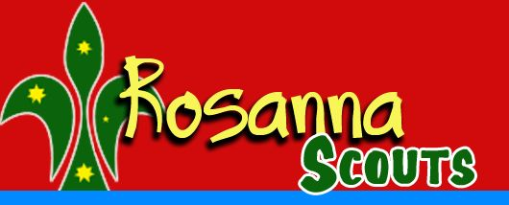
Please come along to see how our Group has progressed in the past year.

